Contents

Unguided Media
Difference between Guided Media and Unguided Media
Satellite Communication
Wireless Sensor Network
Wireless Network
Types of Wireless Network
Wireless Ad-Hoc Network
On line, Off line and Near line storage
UNGUIDED (UNBOUNDED) MEDIA
- It is also known as Wireless Communication OR Unbounded Media.
- Transport electromagnetic waves without using physical conductor.
- The signal broadcast through the air and available to anyone who has a device capable of receiving them.
- It uses following electromagnetic spectrum ranging from 3kHz to 900 THZ.
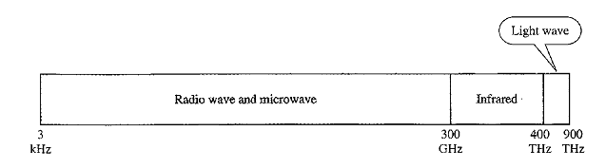

- The section of electromagnetic spectrum is divided into eight ranges is called band.
- Each band is regulated by government authorities.
- These band are rated from very high frequency (VLF) to extremely high frequency(EHF).
- Wireless transmission is divided into 3 group.
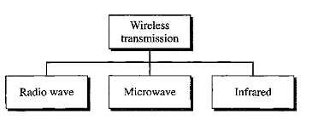
RADIO WAVE
- Electromagnetic waves ranging in frequencies between 3 kHz to 1 GHz are called Radio waves.
- It is omnidirectional i.e. they travel in all the directions from the source. Because of this property, transmitter and receiver need not to be aligned.
- When an antenna transmits radio waves, they are broadcast in all directions.
- This means that sender and receiving antenna don’t have to be aligned.
- A sending antenna send waves that can be received by any receiving antenna.
Advantages
- It can travel long distance. So it is used for long distance broadcasting.
- This waves can be receiving inside building because it penetrate walls easily.
- Useful for multitasking in which one sender and multiple receiver.
Disadvantages
- Leading to a low data rate for digital communication.
Use
It is widely used for AM / FM Radio, Television, Cordless Phone, cellular phone and wireless LAN.

MICROWAVE
- Electromagnetic wave having frequencies between 1 GHz to 300 GHz are called micro wave.
- It is unidirectional these means that the sending and receiving antennas need to be aligned.
- Microwave broadcast is line of sight. Since the tower with the mounted antenna need to be in direct sight of each other, Tower that are far apart need to be very tall.
- Use of certain portion of the band require permission from authorities.
- It require unidirectional antennas that transmit singal only in one direction.
- Two such antennas are
- Dish Antenna
- Horn antenna.
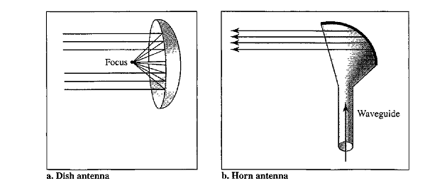
Dish Antenna
- A dish antenna works based on the geometry of parabola. All the lines parallel to the line of sight when hit the parabola, they are reflected by the parabola curve at angles such that they converge at a common point called the focus.
- The dish parabola catches many waves and directs them on the focus.
Horn Antenna
- In horn antenna, outgoing transmission is send through a stem and as it hits the curved head, the transmission is deflect outward as series of parallel beams.
Characteristics
- It is line of sight . Since the towers with the mounted antennas need to be in direct sight of each other, towers that are far apart need to be very tall. Repeaters are need for long distance communication.
- Very high microwares cannot penetrate walls. This characteristics can be disadvantages if receivers are inside building.
- It is relatively wide so high date rate is possible.
Advantage:
- High data rate is possible.
- Very useful when one to one communication is needed between sender and receiver.
Disadvantage:
- It cannot penetrate walls. So receiver inside wall cannot receive signal.
- Attenuation by solid objects: birds, rain, snow and fog.
- Reflected from flat surfaces like water and metal.
Use: Cellular Phones, Satellite network, Wireless LAN

INFRARED
- Electromagnetic wave having frequencies between 300 GHz to 400 THz are called Infrared.
- Used for short range communication in a closed area.
- Cannot penetrate wall So prevent interference between one system to another.
- A short range communication system in one room can not be affected by another system in another room.
- When we use our infrared remote control we don’t interfere with use of remote by our neighbors.
- IrDA (Infrared Data Association) has established standard for communication between devices.
- For IR communication to work, the systems mostly operate in line-of-sight mode which means that there must be no obstruction between the transmitter (source) and receiver (destination).
Use:
- Infrared is used in television remote controls and security systems.
- Use in keyboard, mouse, PC and Printer with IrDA port that allow them to communicate with computer.
Advantages
- Provide 75 kbps speed for distance up to 8m.

Guided Media | Unguided Media
- Signal is transmitted by establishing a physical path between the source and destination. | - No physical path is established between the source and destination ; signal are propagated through air.
- Guided media are well suited for point to point communication. | - Unguided media are well suited for broadcast communication.
- Example is twisted pair cable, coaxial cable and fiber optic cables. | - Example are microware satellite, infrared waves and radio waves.

SATELLITE COMMUNICATION
- Satellite is a device which revolves around the earth either for collecting useful information or for helping transfer of information.
- Satellite communication can be referred as a microwave relay station.
- A satellite links two or more ground based (earth) station that transmit or receive microwaves.
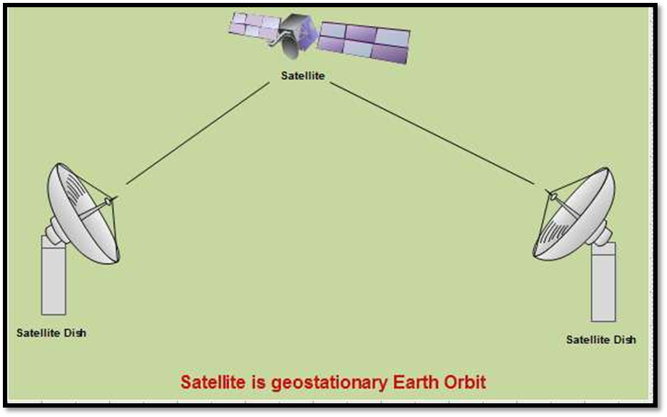
- Once a satellite receives any signal on a frequency (uplink) , it repeats or amplifies that signal and sends it back to earth on a separate frequency (downlink).
- The area shadowed by the satellite, in which the information or data can be transmitted and received is called the footprint.
- Satellites are generally set in geostationary orbit directly over the equator which rotate in synchronization with the earth.
- These geostationary orbits are placed approximately 36000 km above the earth’s surface and satellite placed in this orbit are known as geostationary satellites.
- At that altitude and in an equatorial orbital slot, the satellite revolves around the earth with the same speed as of that the speed of revolution of earth and maintains its relative position over the same spot of the earth's surface.
- Consequently, transmit and receive earth stations can be pointed reliably at the satellite for communications purposes.
- High frequency signals are especially susceptible to attenuation in the atmosphere. Therefore, in case of satellite communication two different frequencies are used as carrier frequencies to avoid interference between incoming and outgoing signals. These are:
- Uplink Frequency: It is the frequency used to transmit signal from earth station to satellite. The uplink signal can be made stronger to cope better with atmospheric distortion. The antenna at transmitting side is centered in a concave. The receiving antenna, similarly, is centered in a concave metal dish, which serves to collect the maximum amount of incoming signal.
- Downlink Frequency: It is the frequency used to transmit the signal from satellite to earth station. In other words, the downlink transmission is focused on a particular footprint, or area of coverage. The lower frequency, used for the downlink
- It is also kind of line of sight transmission and the best frequency for it is in the range of 1 to 10 GHz.
Application
- Major application of satellite communication are long distance telephone transmission, weather forecasting, global positioning, television and many more.

WIRELESS SENSOR NETWORK
- It is a collection of sensing devices that can communicate wirelessly
- Wireless sensor networks are large-scale networks of relatively small nodes, called sensor nodes.
- Each device can sense, process, and talk to its peers typically, centralized collection point (sink or base station)
- Such a node consists of some sensing circuitry, a microcontroller, some small amount of memory, a wireless transceiver and a battery.
How it work?
- A sensor network consists of multiple detection stations called sensor nodes, each of which is small, lightweight and portable. Every sensor node is equipped with a transducer, microcomputer, transceiver and power source. The transducer generates electrical signals based on sensed physical effects and phenomena. The microcomputer processes and stores the sensor output. The transceiver receives commands from a central computer and transmits data to that computer. The power for each sensor node is derived from a battery
How It Differ from Wireless Network?
- Sensor networks differ from "traditional" wireless networks (ad-hoc networks or wireless LANs) in many respects, including:
- The nodes do not belong to individual and independent users, but are expected to collaborate closely in monitoring and controlling the physical environment.
- Sensor networks can have very large numbers of nodes, up to (tens of) thousands.
- The sensor nodes are severely restricted in terms of memory, processing capacity and, most important, and energy.
Used In: Application tasks ranging from environmental monitoring, surveillance systems, building automation, Air traffic Control, Robot Control, Heath care automation and more.

WIRELESS NETWORK
- Wireless networks are computer networks that are not connected by cables of any kind.
- Wireless networks use radio waves to connect devices such as laptops to the Internet, the business network and applications.
- This provides freedom of movement and the ability to extend applications to different parts of a building, city, or nearly anywhere in the world.
- It is getting popular nowadays due to easy to setup feature and no cabling involved.
- You can connect computers anywhere in your home without the need for wires.
Advantages
- Convenience: The wireless nature of such networks allows users to access network resources from nearly any convenient location within their primary networking environment
(a home or office).
- Mobility: With the emergence of public wireless networks, users can access the internet even outside their normal work environment. Most chain coffee shops, for example, offer their customers a wireless connection to the internet at little or no cost.
- Productivity: Users connected to a wireless network can maintain a nearly constant affiliation with their desired network as they move from place to place. For a business, this implies that an employee can potentially be more productive as his or her work can be accomplished from any convenient location.
- Deployment: Initial setup of an infrastructure-based wireless network requires little more than a single access point. Wired networks, on the other hand, have the additional cost and complexity of actual physical cables being run to numerous locations
- Expandability: Wireless networks can serve a suddenly-increased number of clients with the existing equipment. In a wired network, additional clients would require additional wiring.
- Cost : Wireless networking hardware is at worst a modest increase from wired counterparts. This potentially increased cost is almost always more than outweighed by the savings in cost and labor associated to running physical cables.
Disadvantages
- Security: Wireless networks may choose to utilize some of the various encryption technologies available. Some of the more commonly utilized encryption methods, however, are known to have weaknesses that a dedicated adversary can compromise.
- Range: The typical range of a common 802.11g network with standard equipment is on the order of tens of meters. While sufficient for a typical home, it will be insufficient in a larger structure. To obtain additional range, repeaters or additional access points will have to be purchased. Costs for these items can add up quickly.
- Reliability: Wireless networking signals are subject to a wide variety of interference, as well as complex propagation effects that are beyond the control of the network administrator.
- Speed: The speed on most wireless networks (typically 1-54 Mbps) is far slower than even the slowest common wired networks (100Mbps up to several Gbps).
TYPES OF WIRELESS NETWORK
- WLAN: Wireless Local Area Networks
- WPAN: Wireless Personal Area Networks
- WMAN: Wireless Metropolitan Area Networks
- WWAN: Wireless Wide Area Networks
WPAN: Wireless Personal Area Networks
- Wireless personal area networks (WPANs) interconnect devices within a relatively small area, that is generally within a person's reach.
- For example, both Bluetooth and infrared provides a WPAN for interconnecting a headset to a laptop.
- ZigBee also supports WPAN applications
WLAN: Wireless Local Area Network
- A WLAN links two or more devices over a short distance using a wireless distribution method, usually providing a connection through an access point for Internet access.
- The use of spread-spectrum or OFDM technologies may allow users to move around within a local coverage area, and still remain connected to the network.
- A WLAN allows you to connect your computers without wires or cables.
- With a wireless LAN, employees can have easy, convenient access to documents, emails, applications, and other network resources, so they can roam anywhere.
- A wireless LAN makes this easy by using radio waves or infrared signal to let mobile devices connect and communicate within a certain area.
- Fixed wireless technology implements point-to-point links between computers or networks at two distant locations.
- It is often used in cities to connect networks in two or more buildings without installing a wired link.
- Typically used in area where computers are move quite often.
- Security remain an main issue in WLAN.
- Implemented using Access point in existing LAN or new WLAN.
- WEP ( Wired Equivalent Privacy) protocol used for WLAN that encrypt data.
- Products using the IEEE 802.11 WLAN standards are marketed under the Wi-Fi brand name.

WMAN: Wireless Metropolitan Area Networks
- Wireless metropolitan area networks are a type of wireless network that connects several wireless LANs.
- WiMAX is a type of Wireless MAN and is described by the IEEE 802.16 standard.
WWAN: Wireless Wide Area Networks
- WWAN are wireless networks that typically cover large areas, such as between neighboring towns and cities, or city.
- These networks can be used to connect branch offices of business or as a public internet access system.
- The wireless connections between access points are usually point to point microwave links using parabolic dishes on the 2.4 GHz band.
- A typical system contains base station gateways, access points and wireless bridging relays
DIFFERENCE : WLAN Vs WIRED LAN
Wired LAN | Wireless LAN
Require cable to connect your computers | Allows you to connect your computers without wires or cables
Use guided media to transfer data. | Use unguided media to transfer data.
Commonly used in fixed network. | Commonly used in area where computers are moved often.
Faster than WLAN. | Slower than LAN.
Provide better security than WLAN. | Less secure than LAN.
Less convenient to user because it is fixed network. | More convenient to user because user access it from anywhere.
Hard to install than WLAN. | Easier to install than LAN.

Wi-Fi
- Full Form: Wireless Fidelity
- Wi-Fi describes the implementation of WLAN.
- Wi-Fi is a technology and set of standards that allows for the implementation of WLANs.
- WiFi (Wi-Fi) is a term used for a family of products that work in WLAN networks.
- WIFI is a service & WLAN is application which uses the wifi/wimax service.
- Wi-Fi Alliance is a network of companies that bring Wi-Fi technology.
BLUETOOTH
- It is open wireless technology standard for exchanging data over short distance.
- It is a IEEE 802.15.1 specification for the use of low-power radio communication to link phones, computers and other network devices for short distance.
- Designed primarily to support wireless networking devices .
- Typically cover upto 10 meter area.
- Communicate at less than 1mbps speed.
- Bluetooth network feature dynamic topology called PICONET or PAN.
- It contain min. two or max. 8 Bluetooth devices.
- Compare with Wi-Fi it is slower, used in limited range and support fewer devices.
- Name borrowed from Herald Bluetooth - A king in Denmark.
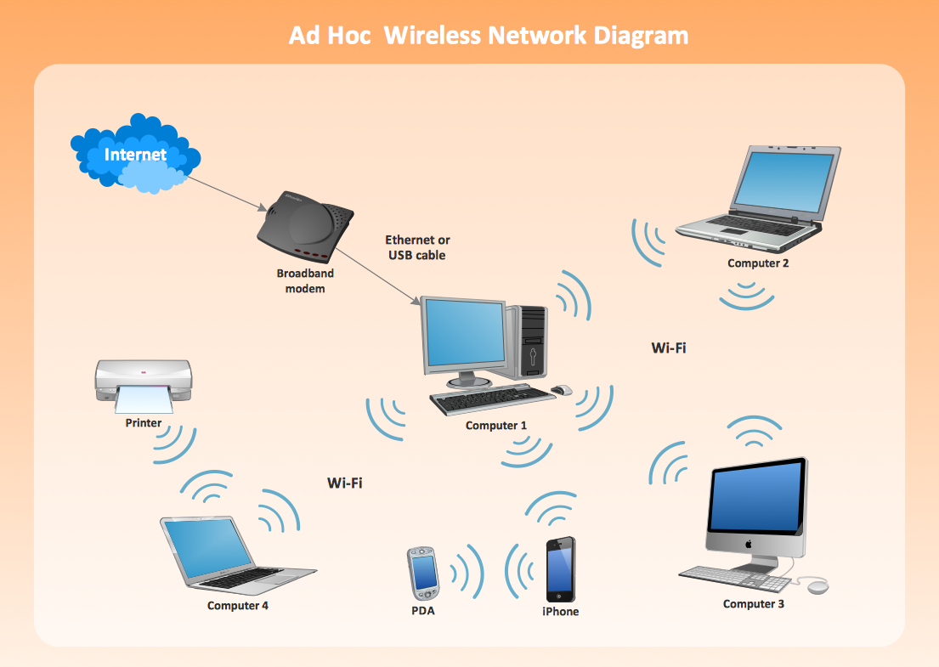
WIRELESS AD-HOC NETWORK
- Definition: Wireless Ad-Hoc Network is network in which machines or devices are communicated Peer to peer use of Wi-Fi technology without passing data through an access point (AP)
- It is a decentralized types of wireless network.
- The network is ad hoc because it does not rely on a pre-existing infrastructure, such as routers in wired networks or access points in managed (infrastructure) wireless networks.
- The network is ad-hoc because each node is willing to forward data for other nodes, and so the determination of which nodes forward data is made dynamically based on the network connectivity.
- Instead, each node communicate directly with each other.
- All wireless device within range of each other to discover and communicate in peer to peer fashion without involving central access point.
- Using the Network Setup, devices such as PSP, Laptops, and other portable gaming consoles can search, share and link each other within range without using a router or a hub.
- To set up ad-hoc wireless network, each wireless adapter must be configured for ad-hoc mode versus the alternative infrastructure mode.
- In addition, all wireless adapter on the ad-hoc network must use the same SSID.
- It tends to feature a small group of devices all in very close proximity to each other.
- Performance suffer as the number of devices grows.
Advantages
- No infrastructure needed
- Can be deployed quickly, where there is no wireless communication infrastructure present
- Can act as an extension to existing networks
- Cost-effective
Disadvantages
- Ad hoc networks are by definition temporary; they cease to exist when members disconnect from them, or when the computer from which the network was established moves beyond the 30-foot effective range of the others.
- You can share an Internet connection through an ad hoc network, but keep in mind that the Internet connection is then available to anyone logging on to a computer that is connected to the network, and thus is likely not very secure.
Application
Mobile ad hoc networks (MANET): A mobile ad hoc network (MANET) is a continuously self-configuring, infrastructure-less network of mobile devices connected without wires.
Vehicular Ad hoc Networks (VANETs): are used for communication between vehicles and roadside equipment. Intelligent vehicular ad hoc networks (InVANETs) are a kind of artificial intelligence that helps vehicles to behave in intelligent manners during vehicle-to-vehicle collisions, accidents.
Smart Phone Ad hoc Networks (SPANs): leverage the existing hardware (primarily Bluetooth and Wi-Fi) in commercially available smart phones to create peer-to-peer networks without relying on cellular carrier networks, wireless access points, or traditional network infrastructure.
Internet based mobile ad hoc networks (iMANETs): are ad hoc networks that link mobile nodes and fixed Internet-gateway nodes.

ON LINE STORAGE
- Online Storage is a browser-based application that allows you to store and access your important files, safely and securely — online.
- Much like a folder on your hard drive, Online Storage allows you to back up your files and stores them in a safe place for you.
- You'll have access to your files 24/7, you can share your files with others
- It is an alternative to traditional local storage (such as disk or tape drives) and portable storage (such as optical media or flash drives).
- It can also be called "hosted storage," "Internet storage" or "cloud storage."
OFF LINE STORAGE
- Offline storage is any storage that is not currently online, live or connected to the computer.
- The data stored in offline storage remains permanently in the storage device even if it’s disconnected or unplugged from the computer after the data has been stored.
- Common examples of offline storage include floppy disks, compact disks and USB sticks.
NEAR LINE STORAGE
- Near-line storage is a type of storage medium that is external to a computer and provides quick and scalable access to storage devices/capacity within an IT environment.
- This term refers to any storage architecture, infrastructure or technology that resides between online and offline storage sources.
- Near-line storage devices include massive array of idle disks (MAID), automated tape libraries and SATA based disk RAID systems.

